Araxis Merge
($269, Win 32 and 64, Mac)
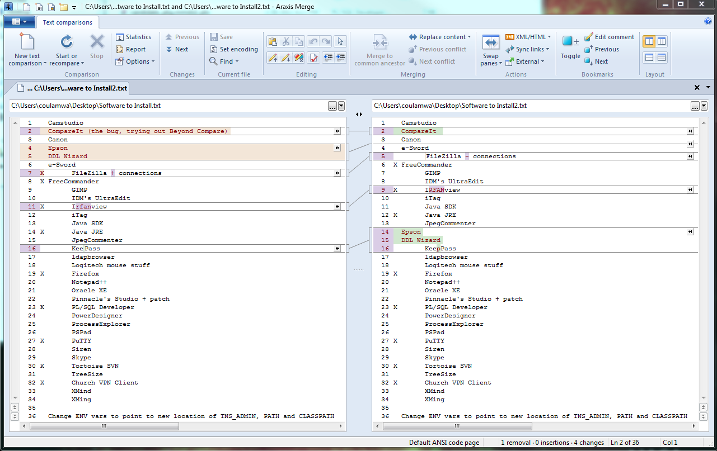
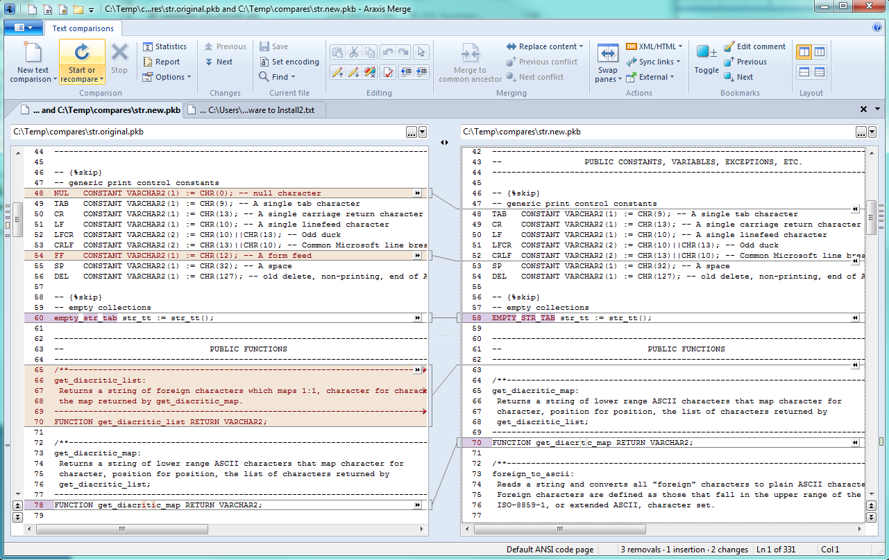
Very disappointed it did not find the moved function.
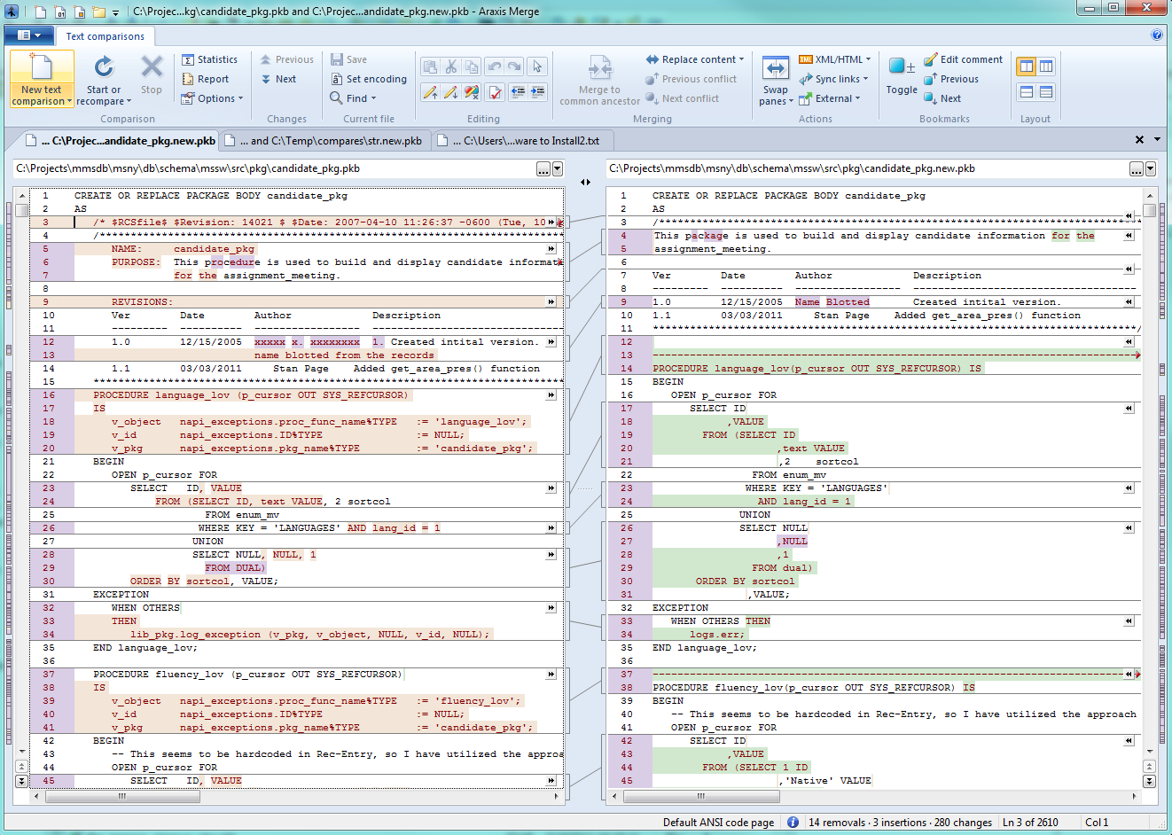

BeyondCompare
($30, Win and Linux)
I miss having a color legend.
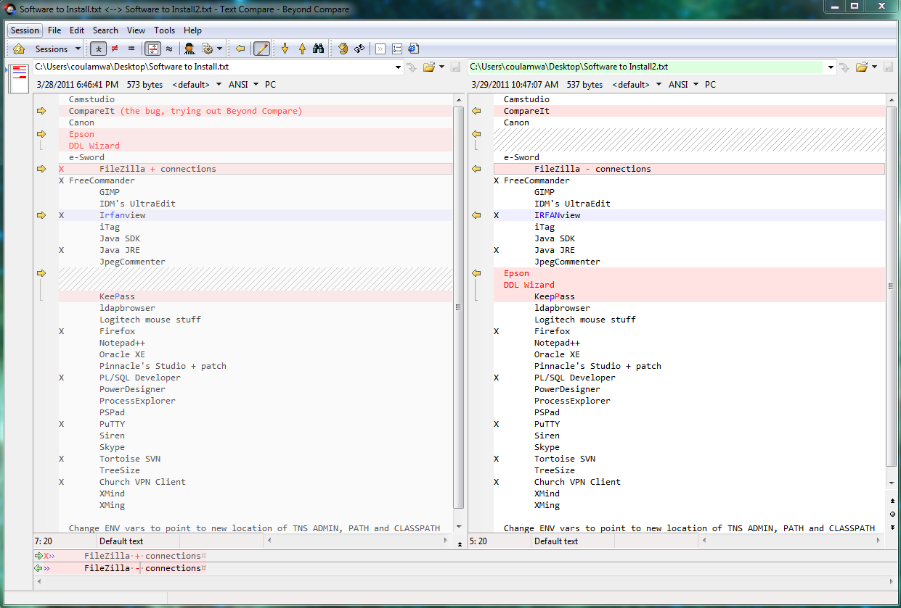
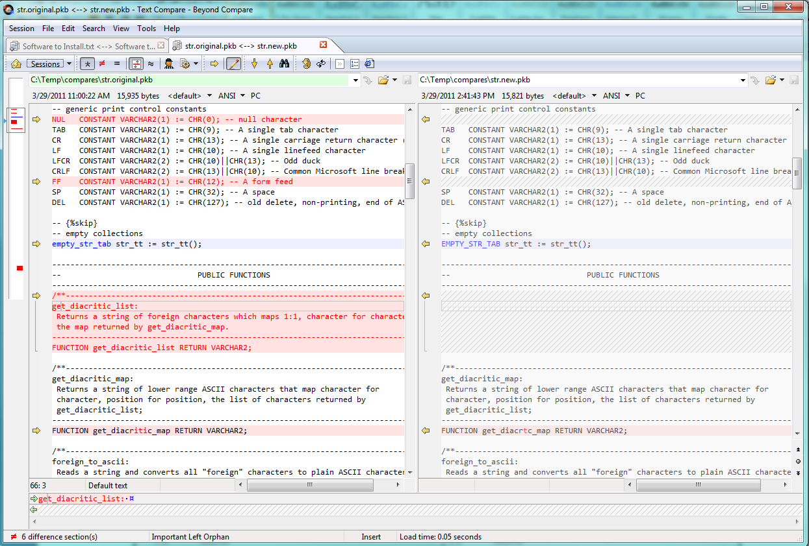
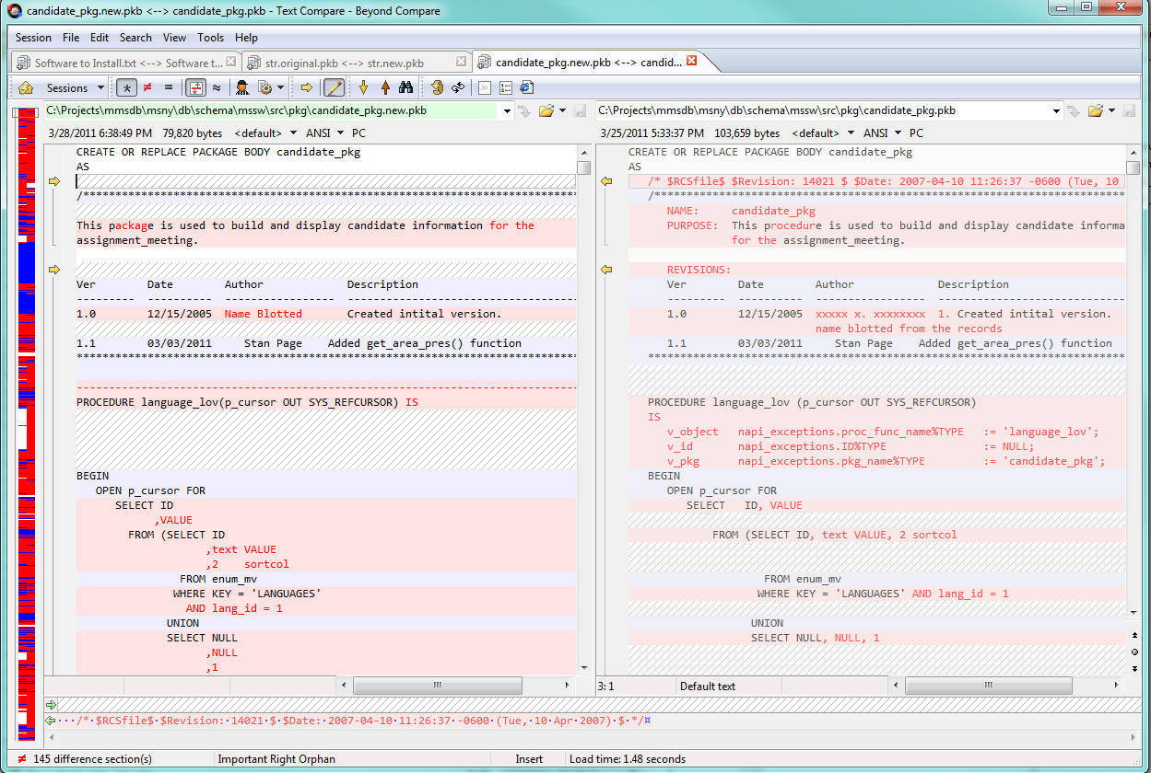

CodeCompare
($50, Win)
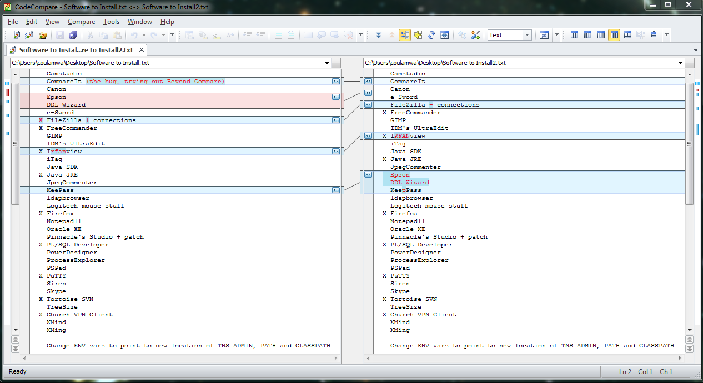
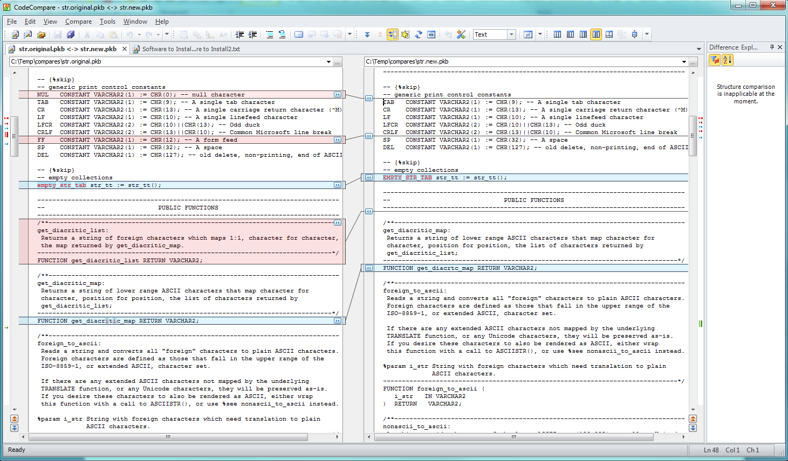
Even has a find similar option that should have found the moved function, but it did not.
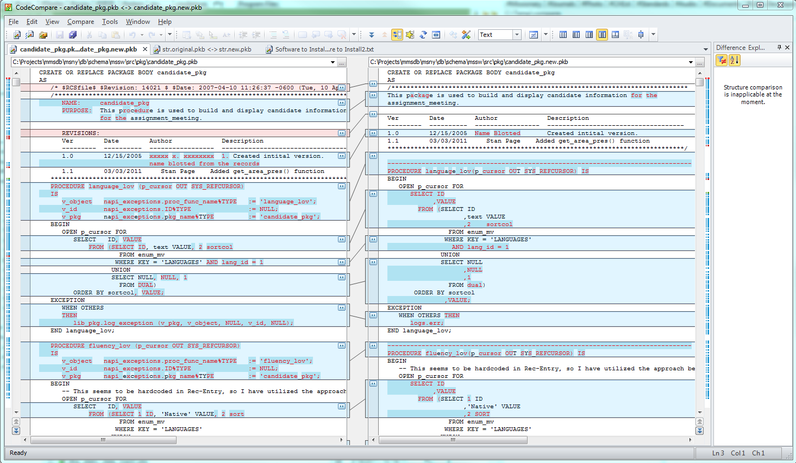

Compare++
($11-$30, Win 32 and 64)
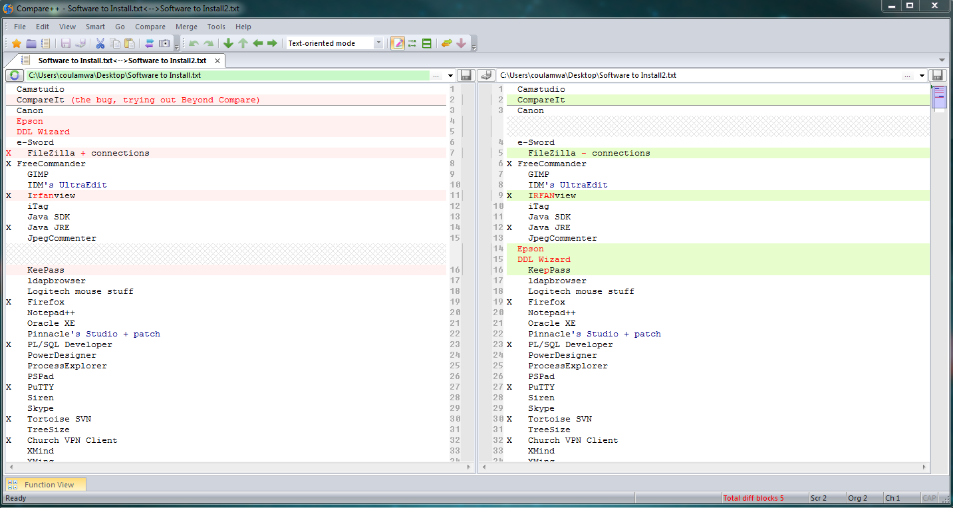
Pretty good! Aligned. Character-mode. Fast enough.
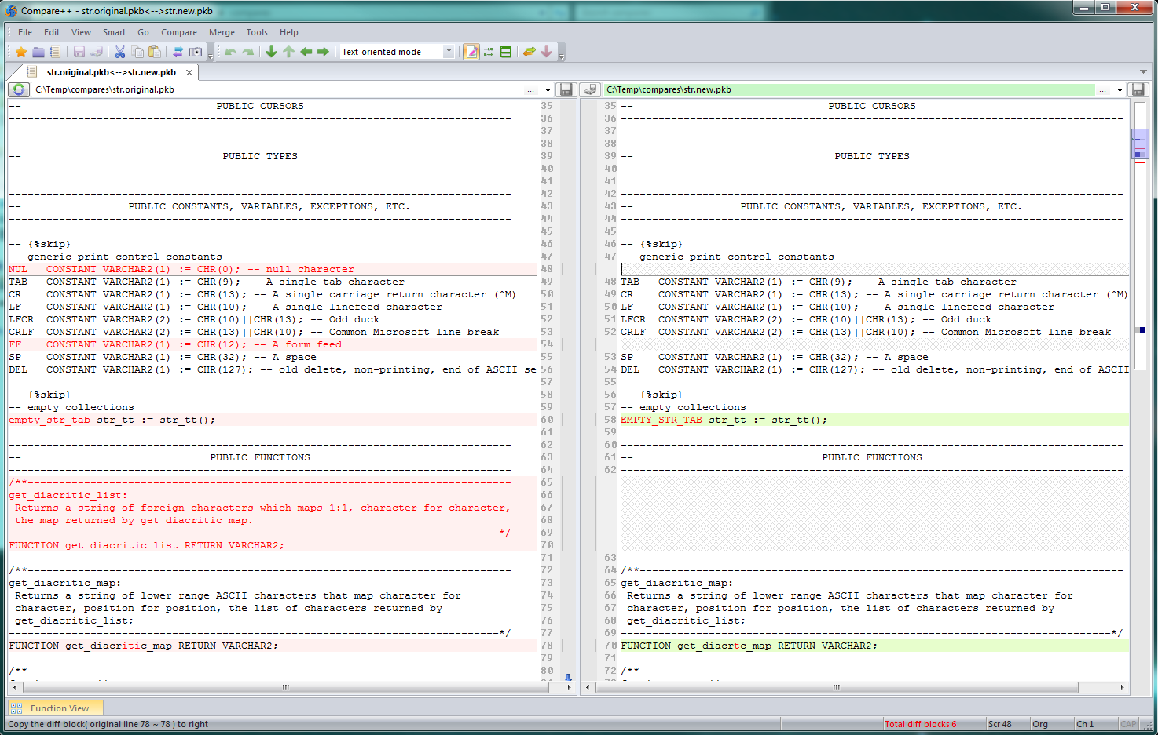
Disappointing. It can supposedly find moved functions, but it failed. When I tried that feature on 2 text files, it crashed. When I tried it on these two package bodies, it just gave me two blank panes.
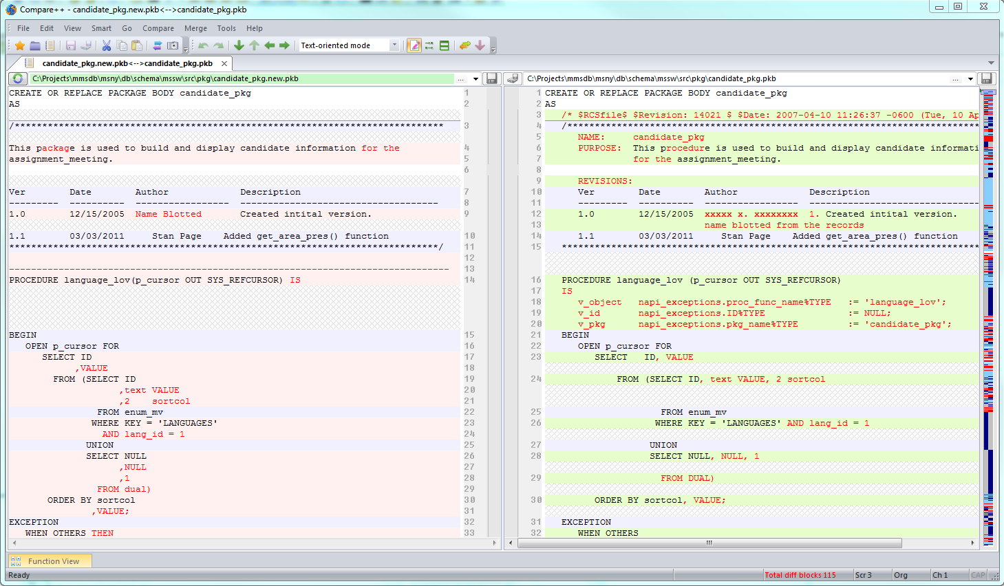

CompareIt 4.01
($25)
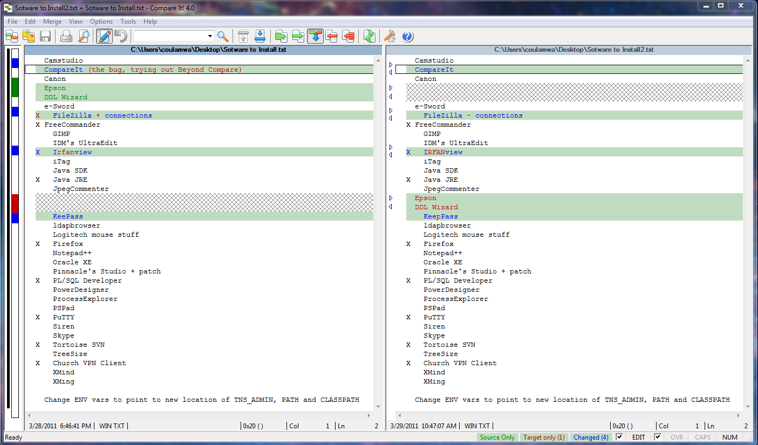
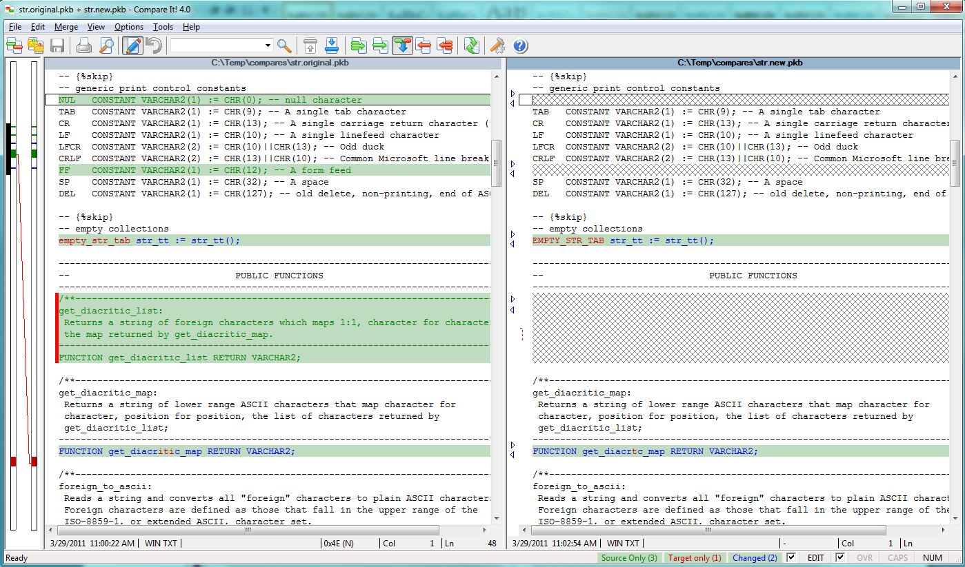
This is most valuable when there have been formatting changes mixed with meaningful code changes:
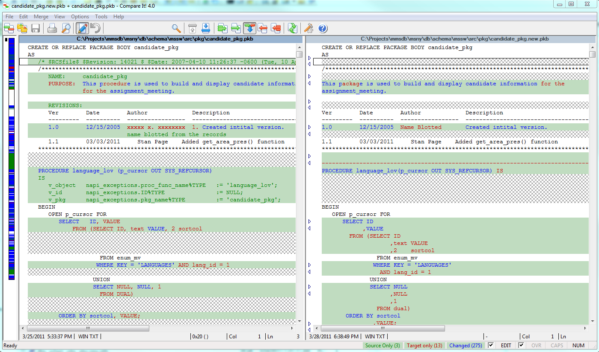

DeltaWalker
($39.95, Win 32, Mac, Linux 32 or 64)
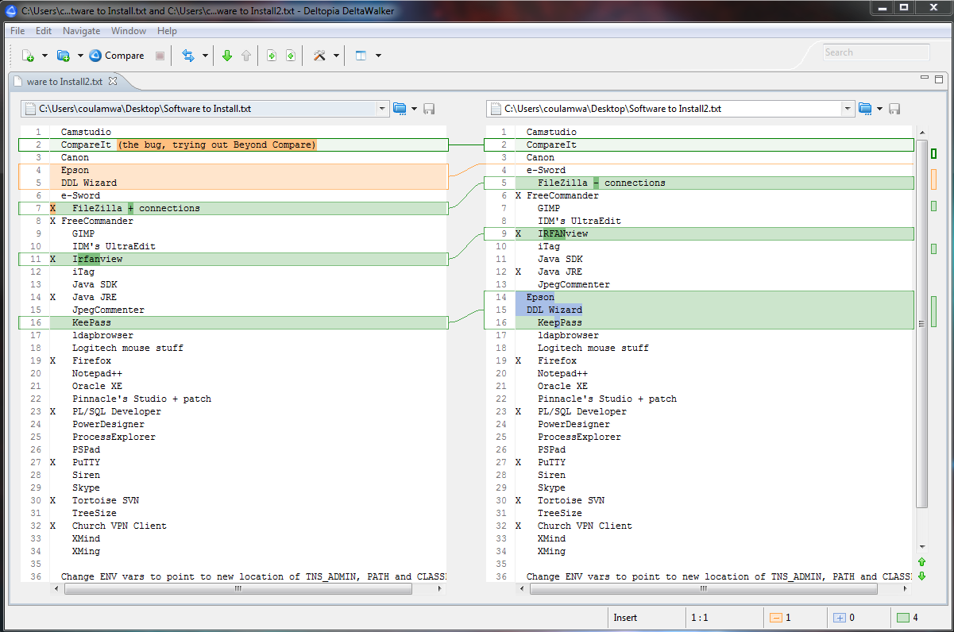
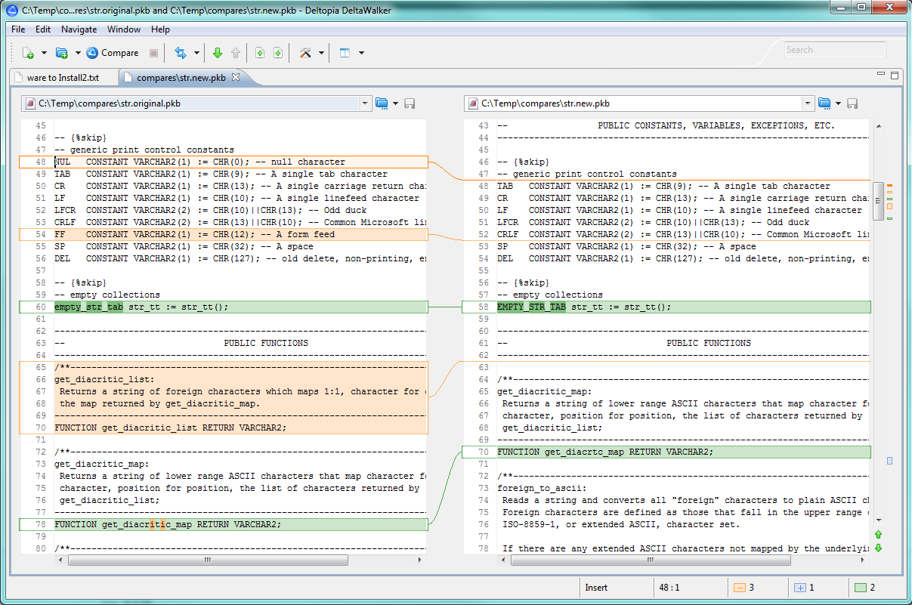
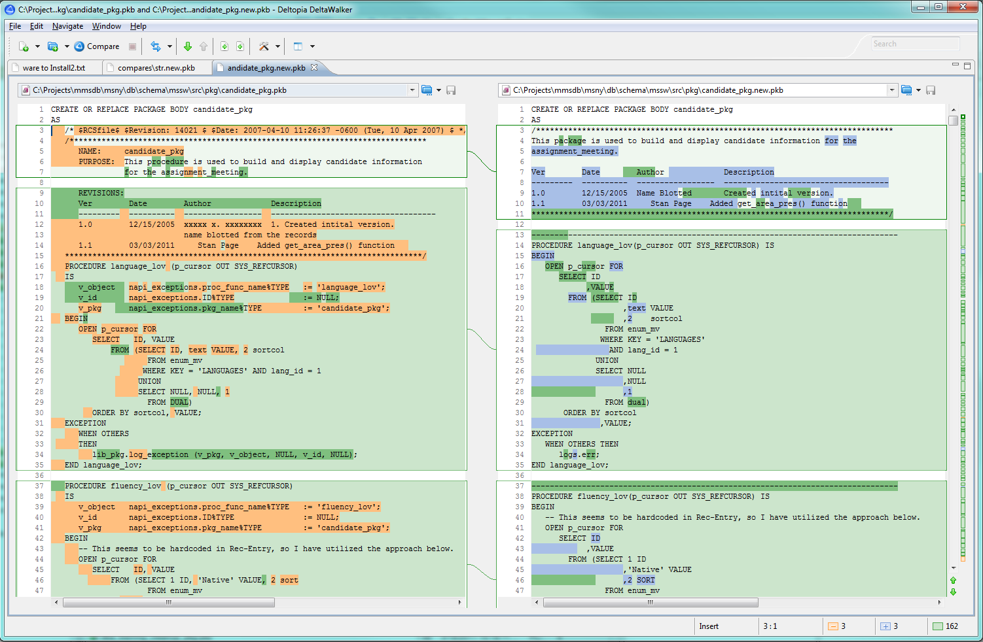

ECMerge
($40/60, Win, Mac, Linux)
Slower than some, but not the worst. Found I had to turn on character-level.
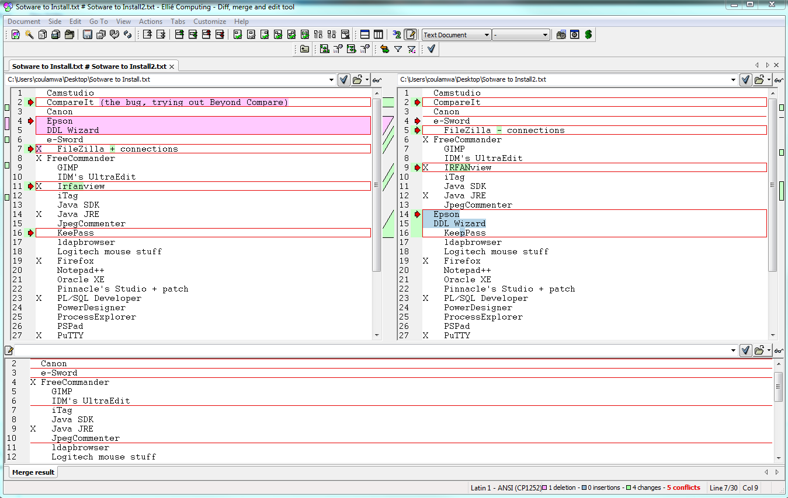
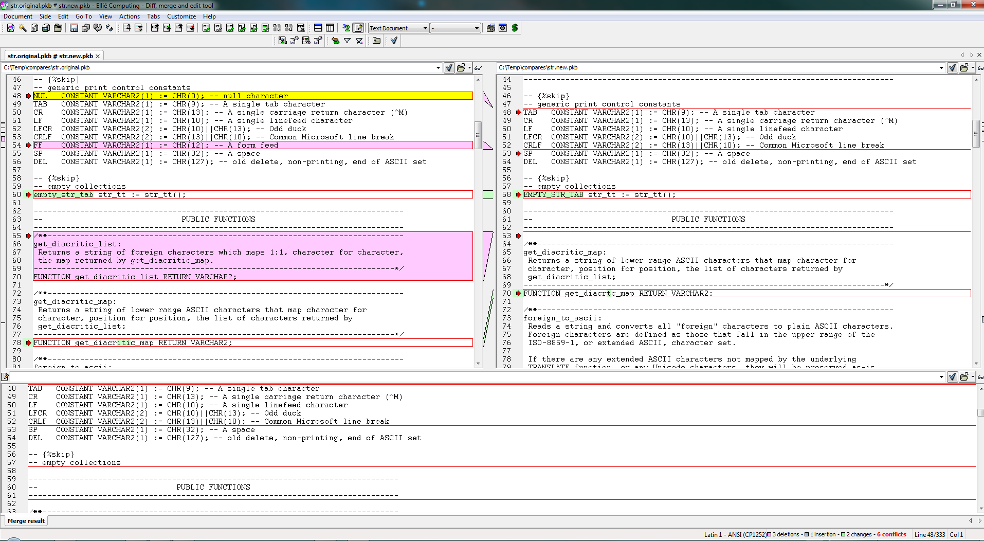
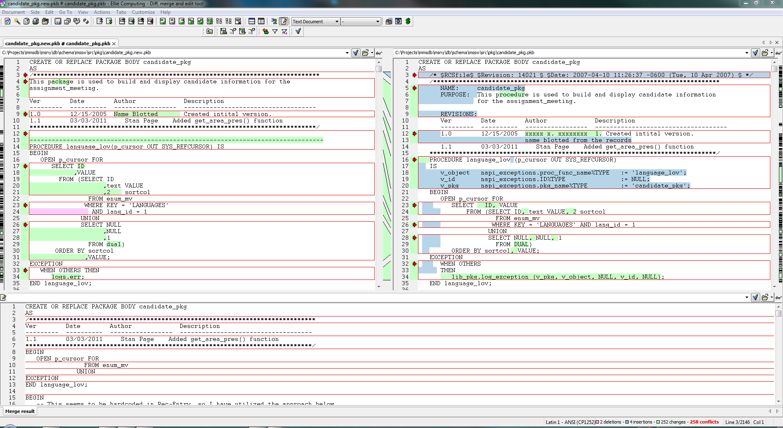

ExamDiff Pro
($35)
Really slowed down the appearance of my context menu (when right-clicking two files to compare). Had to ask for most detailed level comparison, but it does it:
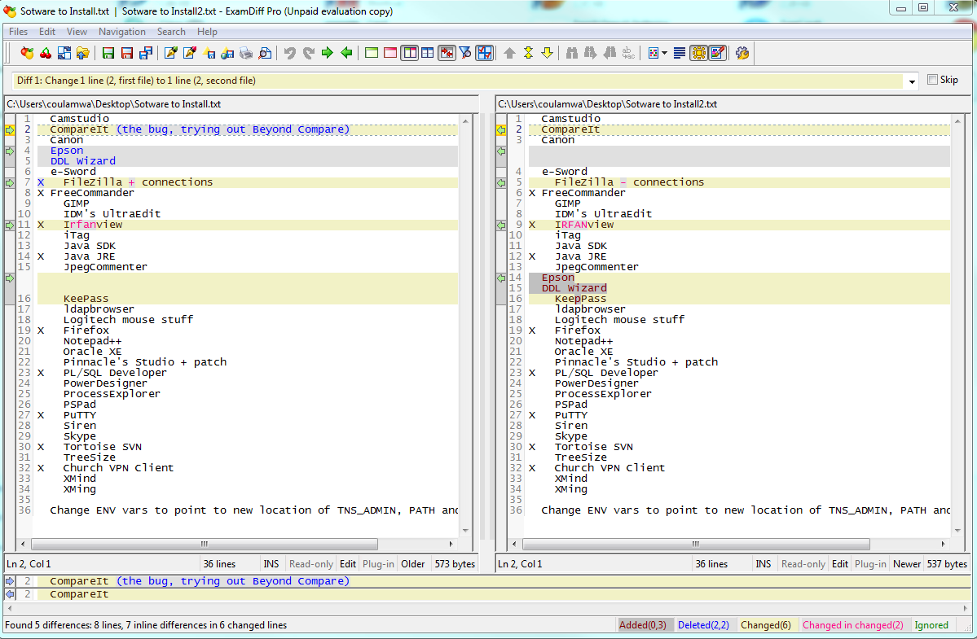
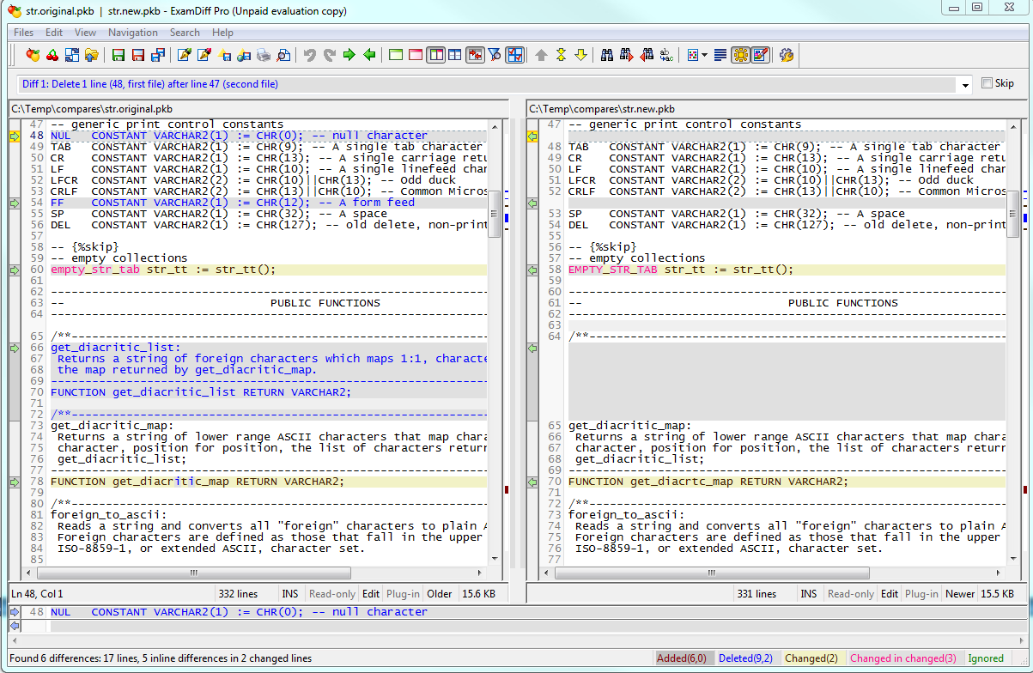
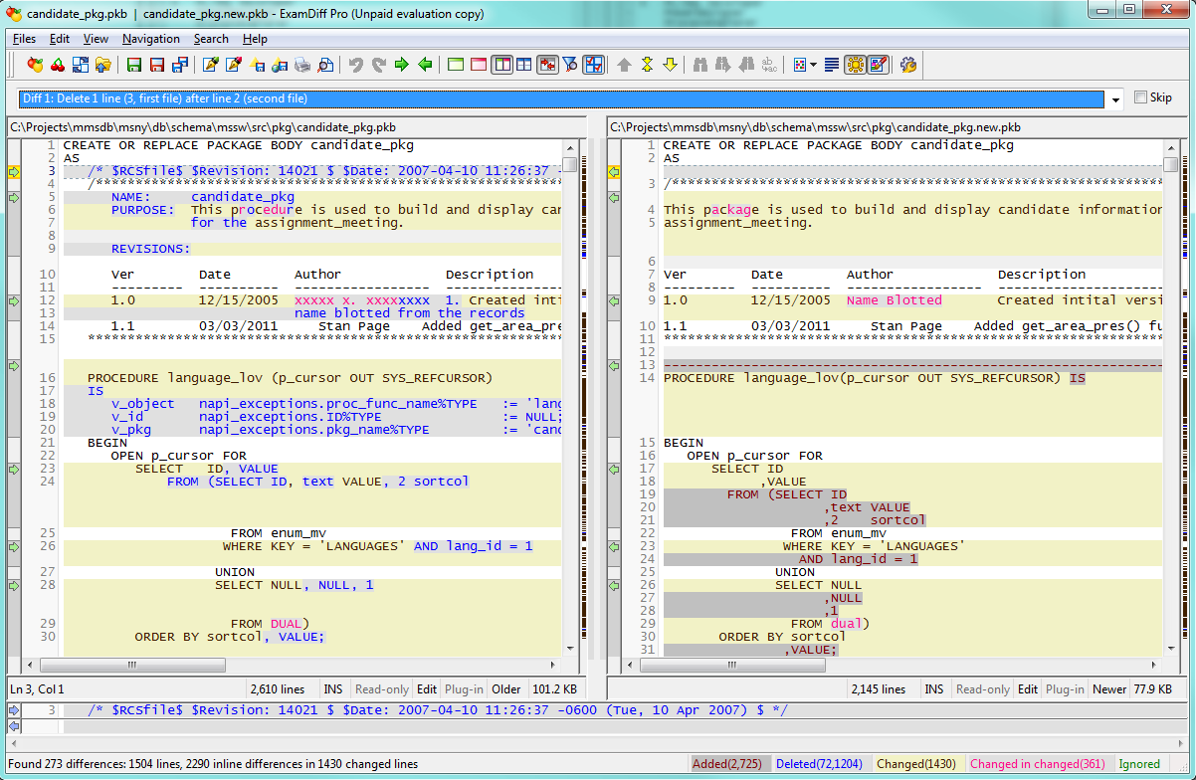
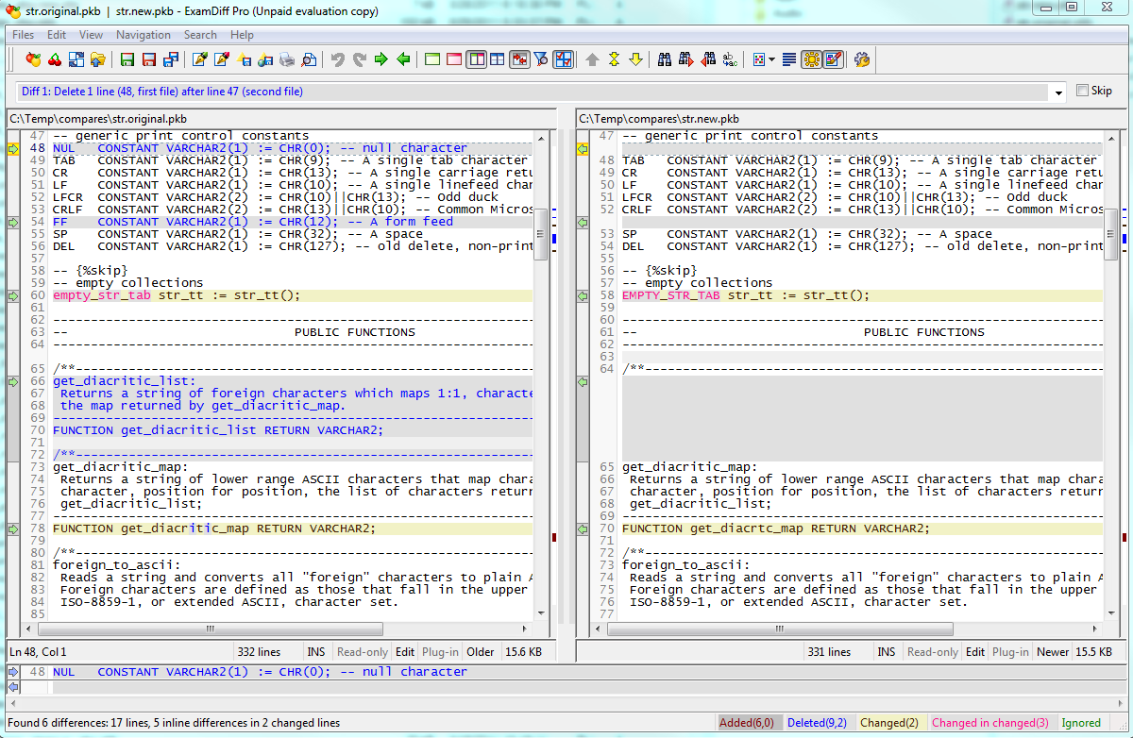

Notepad++ Compare plugin
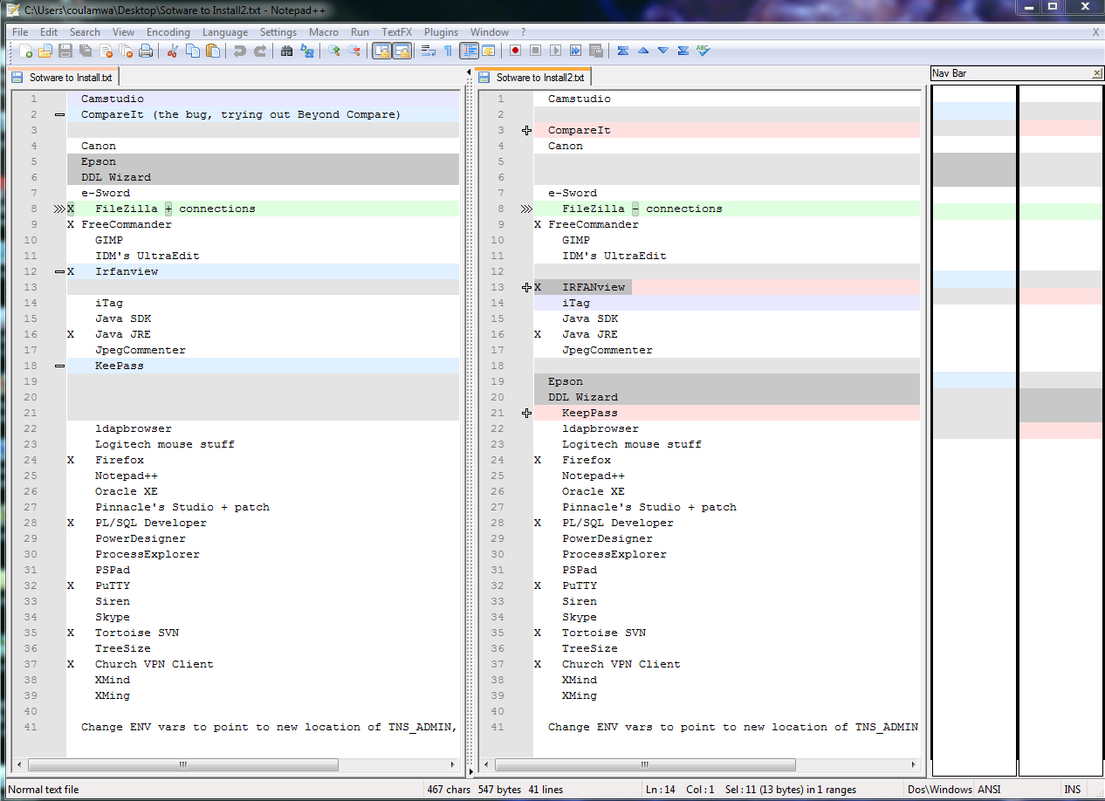
Little better, but loses side-by-side sync with moved section.

Perforce Visual Merge (p4merge) 32 & 64
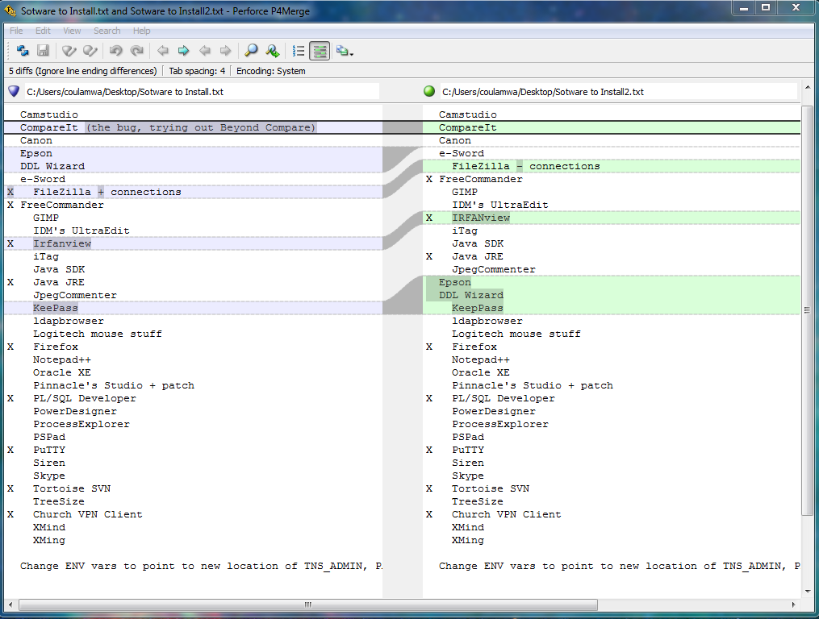
Seems not to have shell integration. No context menu in explorer tools. Too simple, like many of the “garage-ware” tools.
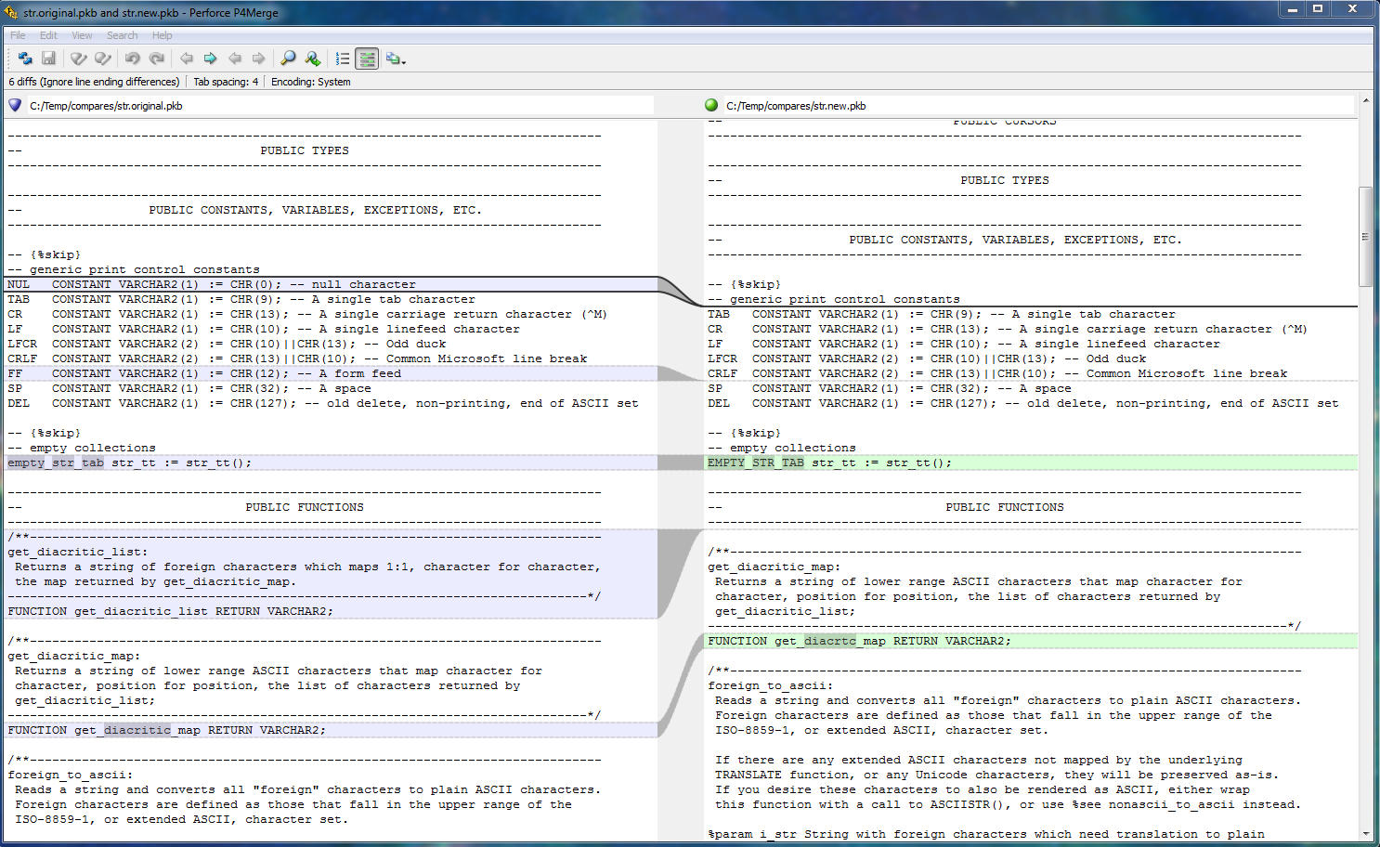

PSPad’s Text Diff
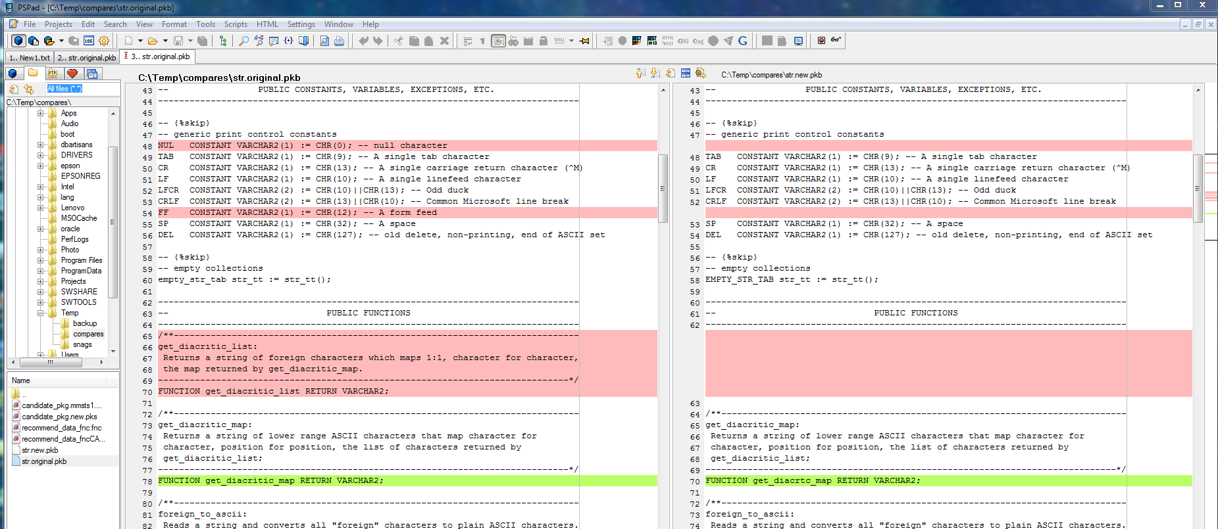
Too simple.

UltraCompare 8.0
($50)
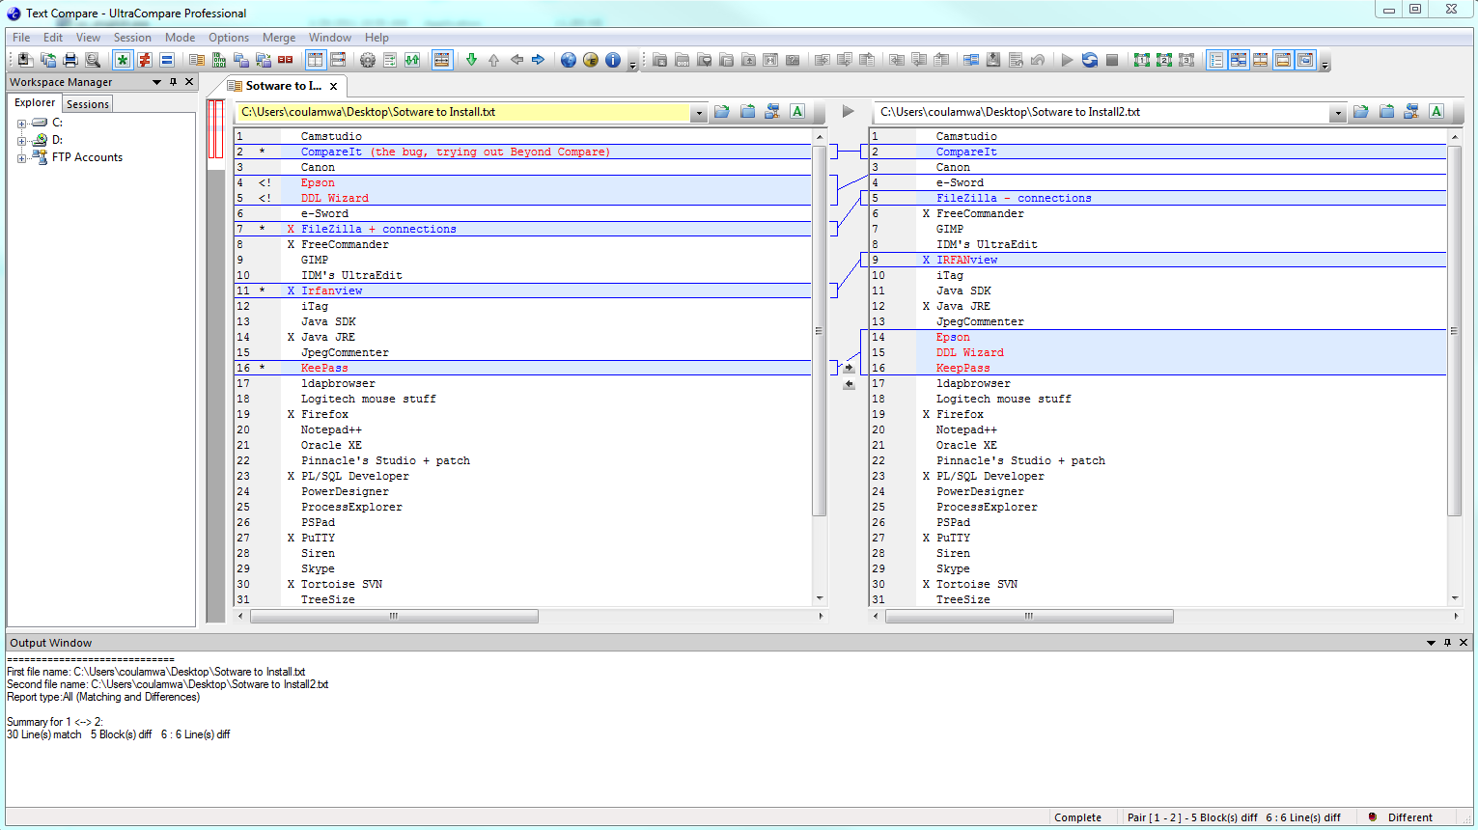
Does OK. Individual changes highlited in-line. I don’t like how it handles the two moved lines though, and how it missed the new “p” in KeepPass. I prefer how CompareIt synchronizes the position of matching lines by using hashed empty lines.
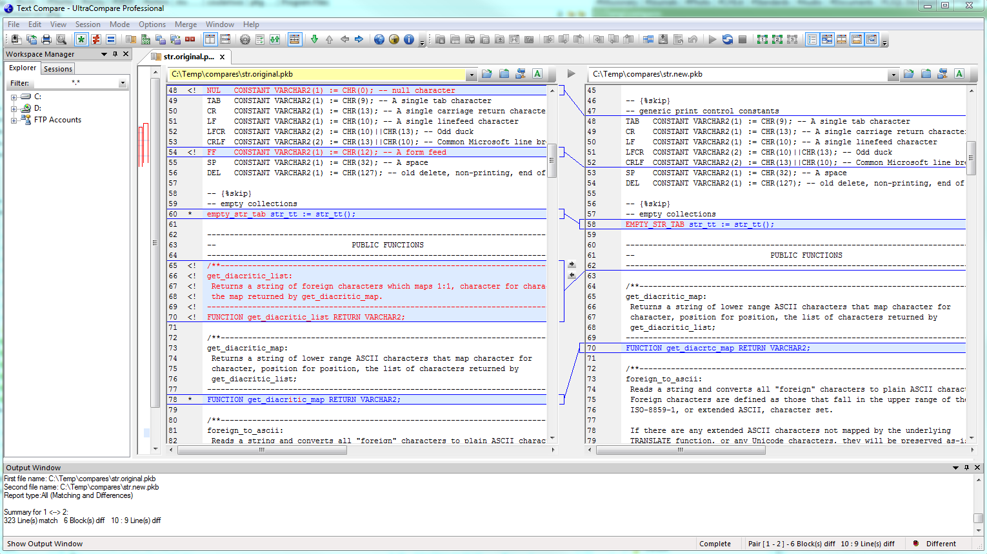
Took about 5-6 seconds, whereas CompareIt was sub-second. This really light blue bars in the change overview pane just don’t help much. First two times I looked at it, missed the ethereal blue bar at the bottom indicating where the moved get_diacritic_list function went to. This initial view makes it look like the function was removed.

WinMerge
(free)
Only tool to find moved Epson DDL Wizard lines. Not out of the box though. Took considerable tweaking of the options to get it looking like this. Doesn’t seem to have option to differently color characters that were deleted.
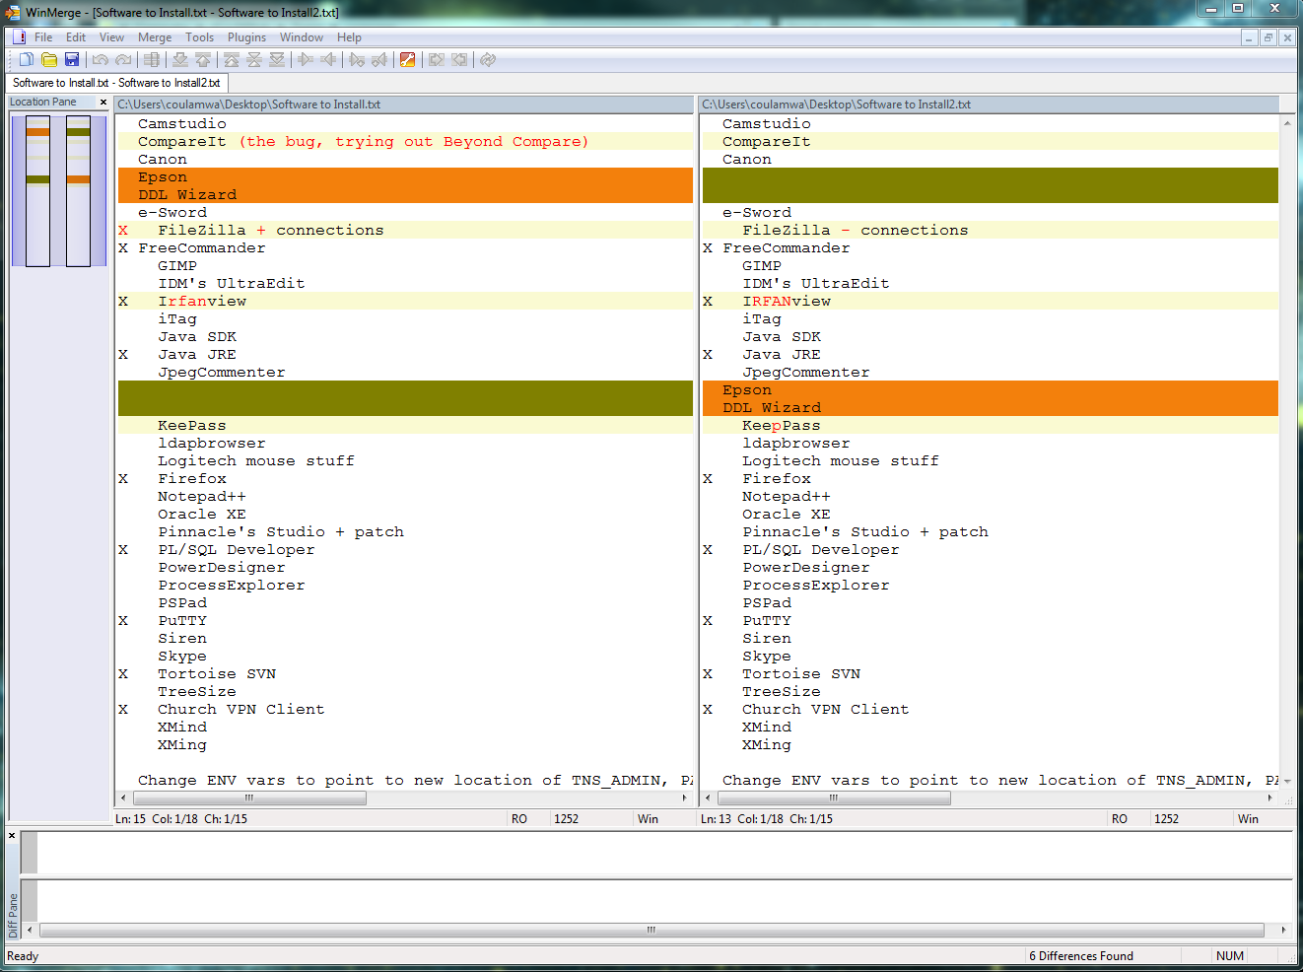
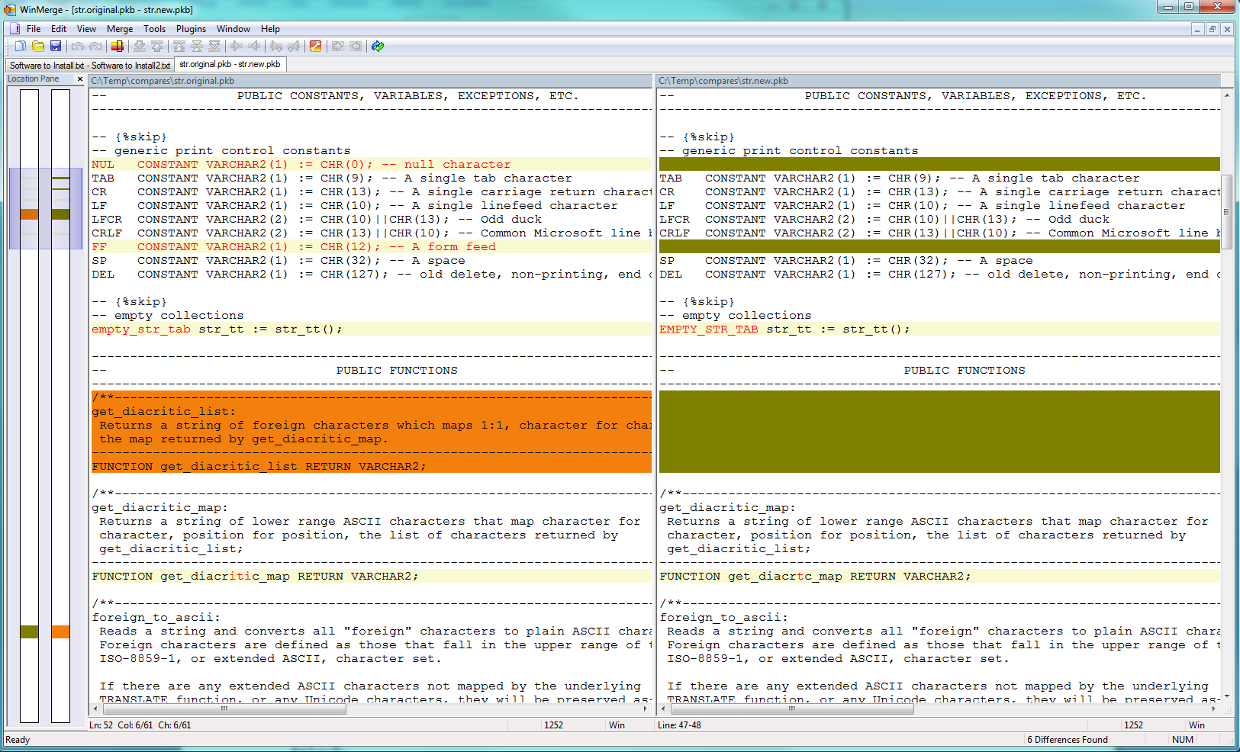
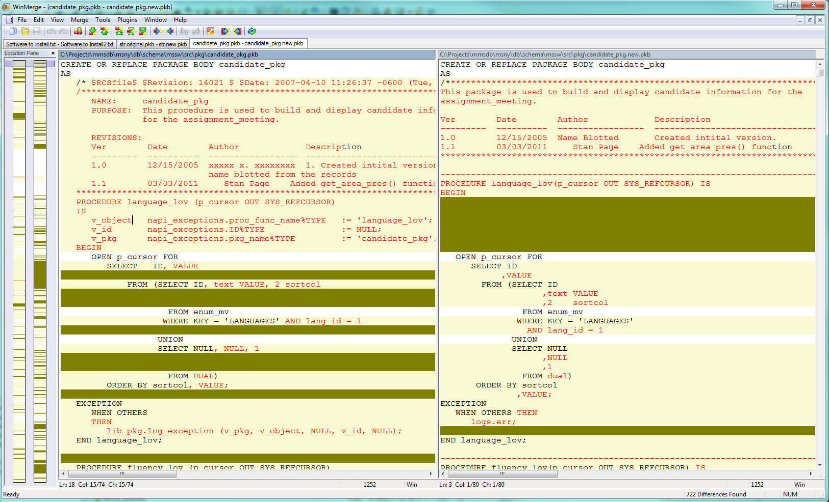

SwiftCompare, tkdiff, and host of other shareware and freeware options tried:
(free junk)
Way too simple to even bother wasting space here talking about it. Just letting the reader know about 12 others were considered.

